Dear Ko Min Thu Aung,
Congratulations on Your Achievement!
Greetings from Strategy First International College.
We are delighted to formally invite you to attend The Graduation Ceremony 2026, proudly organised by Strategy First International College.
Please find the ceremony details below:
Venue: Novotel Yangon Max Hotel
Date: Sunday, 16 August 2026
Time: 8:00 AM to 10:30 AM (Session A)
Important: Graduates attending Session A are required to arrive at the venue by 7:30 AM for registration.
Registration
Students who wish to attend the graduation ceremony are kindly requested to complete their registration no later than 24 July 2026 via the link below:
https://forms.gle/VMxw3iw73XxkWkPQ9
Graduation Gown Collection
Graduation gowns will be available for collection at Panchan Tower Campus from 1 August to 10 August 2026.
Guest Information
This year, The Graduation Ceremony 2026 will be free of charge for both graduates and guests.
Each graduate will be entitled to invite up to two guests only.
Telegram Group
All announcements and updates regarding the graduation ceremony will be shared through the following Telegram group. Please make sure to join:
https://t.me/+KX0a6pnueCZkZTU9
We look forward to celebrating this remarkable milestone with you.
Yours sincerely,
Strategy First Graduation Committee

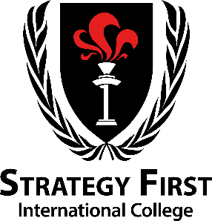 | Strategy First International College  Undergraduate Programme  Myaynigone Teaching Cetre(2)  No. 237, Corner of Uwizara Road and Dhamazedi Road, San Chaung Township,Yangon  Strategy First Education Group Limited.  Contact us  09-450177771,09-442532546  Yangon: +959 250 7171 66~68, info@mystrategyfirst.com  Mandalay: +95 9 444 555 616~617, info.mdy@mystrategyfirst.com  Facebook|LinkedIn|Twitter  www.strategyfirst.edu.mm

